

**Final Project Report**

**Course: ALY6040**

**Data Mining Applications**

**Prof. Joseph M.Reilly**

**Rambhupal Payyavula**

**Introduction:**

This final project aims to build a classification model to estimate the property's price in the Airbnb listings by considering the property's size, longitude, scope, location, and other variables. We performed the Exploratory data analysis to explore the features in the dataset and find if any relationships exist between the price of the property and the other parts of the property.

We have collected this Airbnb properties London dataset from [Inside Airbnb](http://insideairbnb.com/get-the-data/). Please click on the Inside Airbnb link to learn about the data source. This dataset comprises 66,640 observations and twenty-one variables.

We preprocessed the data where we imputed the median and mode in the place of null values, analyzed them, and removed the redundant features in the data. Then we performed exploratory data analysis to explore the data and answer the business questions, and then we performed the data mining.

We have used three models in this project, where one is the clustering model, and the other two are classification models.

1. Gaussian Mixture Model (GMM) for clustering
2. Random forest classification model
3. K-nearest neighbors classification model (K-NN)

We used the GMM model for clustering the location data because the GMM technique disregards cross-sectional dependency and assumes that the panelists' slope coefficients are homogeneous (homogenous panel). So, it best suits our requirements. We used the random forest classification to classify the price since it offers the best accuracy and can also handle large amounts of data with different variables. Moreover, it can balance the dataset when one class is less frequent than other classes, and most important of all, it helps in finding the feature importance. We opted for the K-NN model due to its simplicity, and it is significantly quicker than other training-based algorithms.

**Business Questions:**

Although we aim to estimate the price, we also want to get the answers to the below essential business questions by exploring the data.

1. Which Neighborhood has the highest number of listings?
2. What are the highest and least available room types in the property listings?
3. Most listings are under which price?
4. Do the location and other features significantly impact the price of listings?

**Exploratory Data Analysis:**

We have started our analysis by importing the required libraries to perform the exploratory data analysis. Then we loaded the Airbnb London data into the panda's data frame variable with London's name. The information has been verified after being imported into Panda's data frame. We discovered that the data was appropriately imported into the data frame and had 66,640 observations and 22 features. We also found three types of data stored in these data structure variables: panda’s objects, integer, and floating-point data types. Moreover, we could see some null values in the variables like name, hostname, last review, reviews per month, bedrooms, and beds, and there are 0 non-null values in the license variable.

After examining the dataset for null values, we discovered that there are null values in 6 features, one of which, license, has 100% null values while the other five contribute less than 27%. Then we tried to find the patterns in the missing values and found no patterns in the missing data. Still, the two features, reviews per month and last review have the same percentage of missing values (27 percent), and bedrooms had more than 5 percent null values. All the other variables except license had less than 2.5 percent, which is insignificant. So, we decided to handle those by imputing the mode values (impute missing values with mode in python, n.d.) and median (Pandas Tricks for Imputing Missing Data, n.d.) into categorical and non-categorical features with null.

Characteristics, such as license, which had no data, seemed to us to be useless to our investigation. It is good to have personal data like ids and names. However, when we analyze the group behavior, they are not of much use to our analysis as we estimate the housing price based on the property features, and name, id, and last review date has nothing to do with it. Moreover, revealing such personal data can have privacy concerns. So, we decided to drop the six variables: id, name, host id, hostname, last review, and license. And we left with 15 variables.

After analyzing the descriptive features such as mean, mode, and median, to our surprise, we found inconsistent data in two variables. The fact that two variables had discrepancies caught us off guard as well. For instance, the price cannot be zero, although zero is the lowest value. Similarly, accommodates, which can’t be zero, but the minimum is zero. After seeing all this, we were curious about the number of zeros in each feature. And we found 0s for more than 60 percent of the data for two variables. This means there are no reviews and no availability of listings for more than 60% of data. So, these two variables don’t play a significant role in our analysis. Hence, dropping those two variables. At this point, we were left with 13 variables in our data to perform the analysis. Furthermore, we decided to impute the median for the price and mode for the accommodates as they have zero values, and they contribute less than 0.5 percent and can’t be zero.

Knowing how the data is distributed is significant to get a basic idea of the data we analyze. We used a density plot to examine the dataset's various distributions. A density plot depicts data distribution across a continuous interval or period.

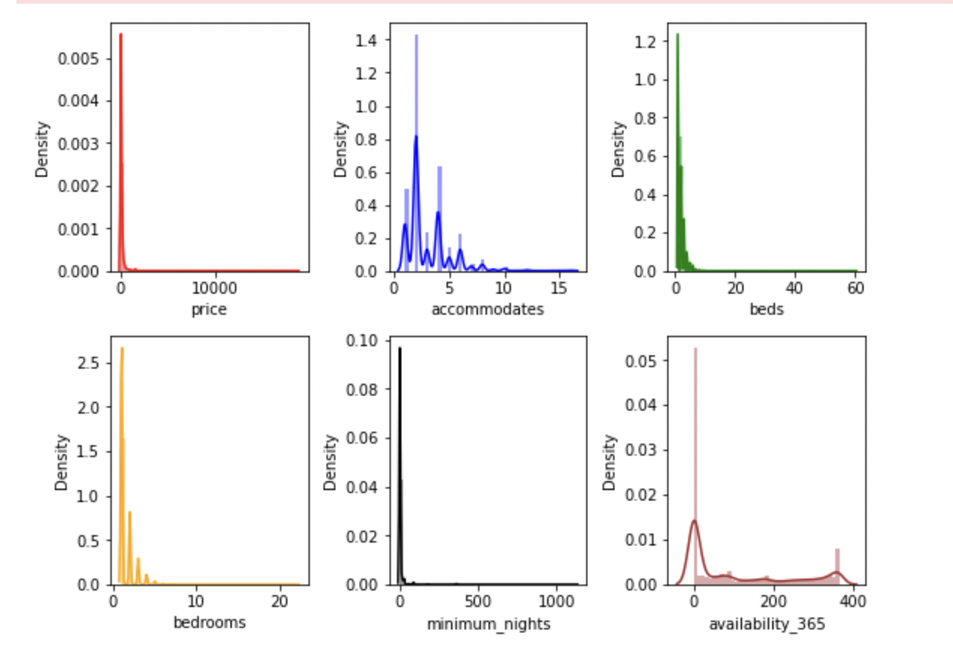

We can see that the price has primarily gathered in the range of 400 values. The number of accommodations has a density of one. The majority of beds are between 0 to 10

**Outliers:**

It is crucial to look at the outliers since they can include blatantly erroneous data. Since outliers might provide vital information about the data we are examining and affect statistical findings, we sought to identify them in the data. This may help in identifying statistical errors and discrepancies. Using the boxplot, outliers in the data may be seen.

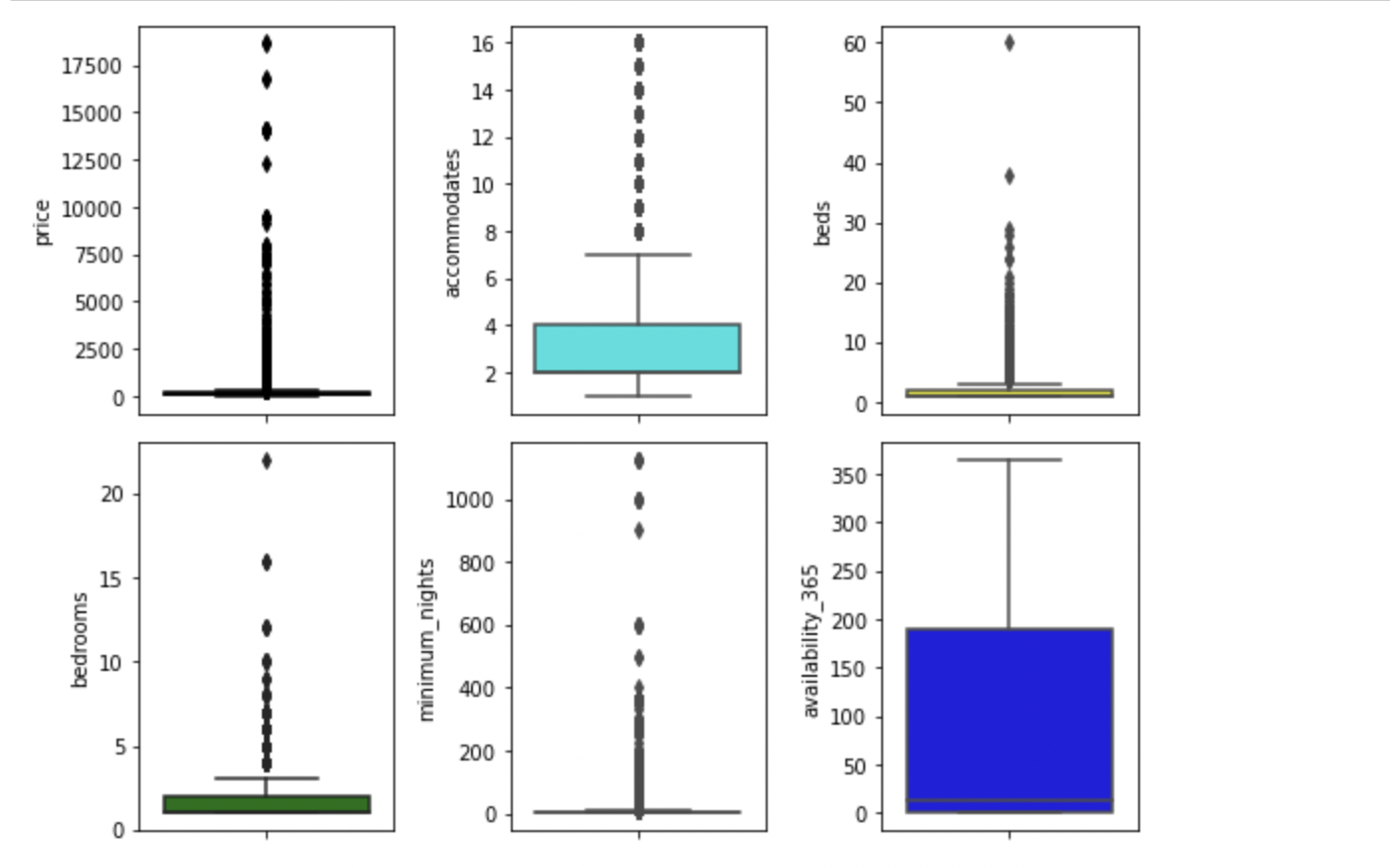

Outliers are present in some variables, but we did not find any suspicious data as the data points are consistent. We are not sure about how significant the outliers are. So, we found the outliers for all the numerical features. Below is the table showing the percentage of outliers.

We discovered that there are outliers, but they make up less than 17% of the total and don't appear suspicious. In our classification model, I decided to keep the outliers as we don’t want to lose the essential details by removing outliers or imputing the mean/median in the place of outliers.

We thought EDA would be an excellent opportunity to explore the data and get the answers to our business questions through the visualizations.

So, we explored the neighborhood, room type, and price distribution based on the longitude and latitude (Plotting univariate histograms, n.d.).

**Which Neighborhood has the highest number of listings?**

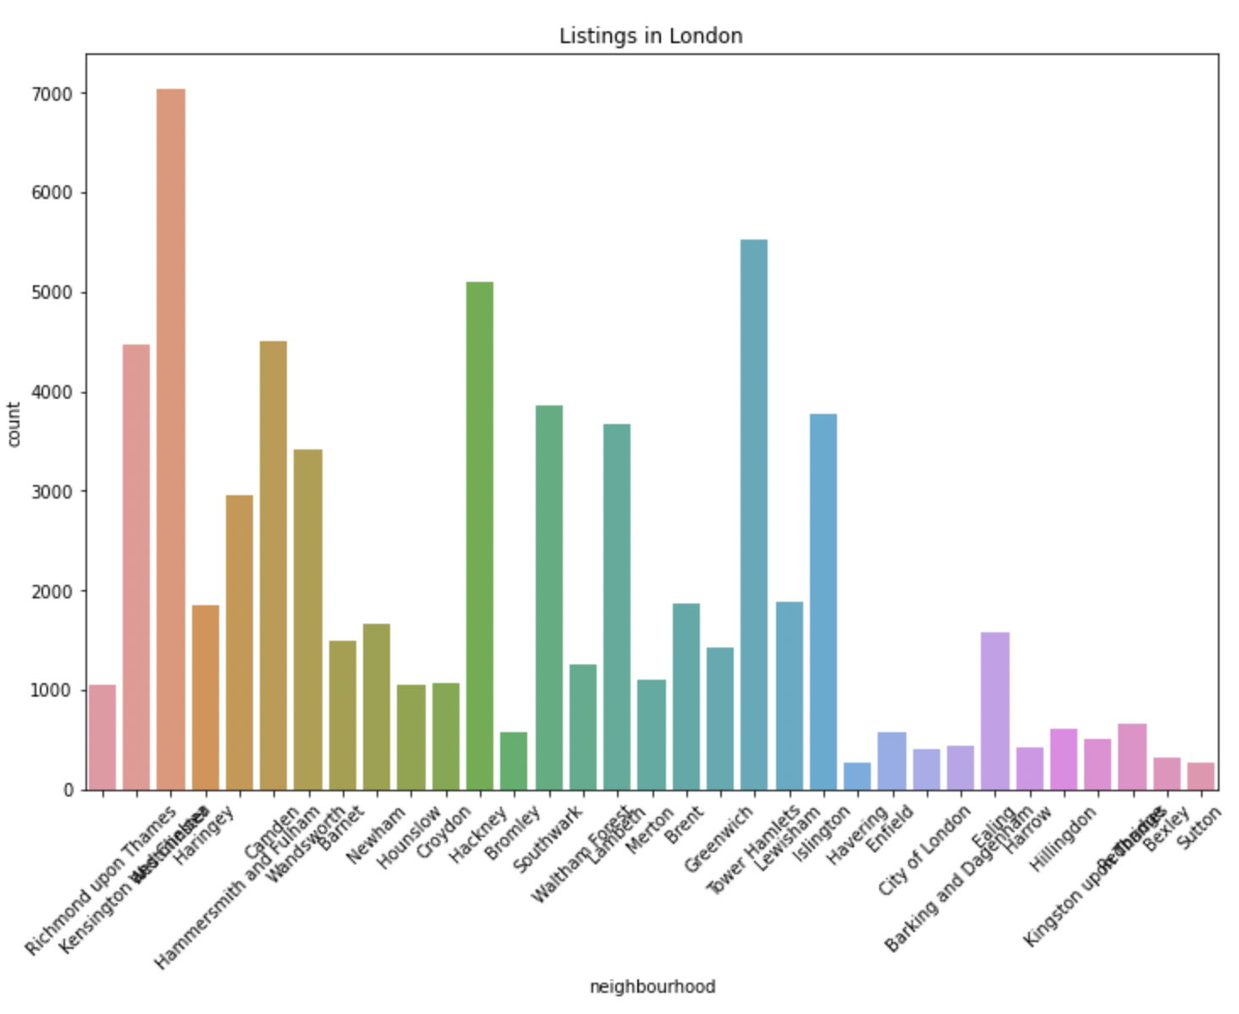

The exciting thing about the above distribution is “Richmond upon Thames” neighborhood has the highest listings, and Islington has the lowest listings.

**What are the highest and least available room types in the property listings?**

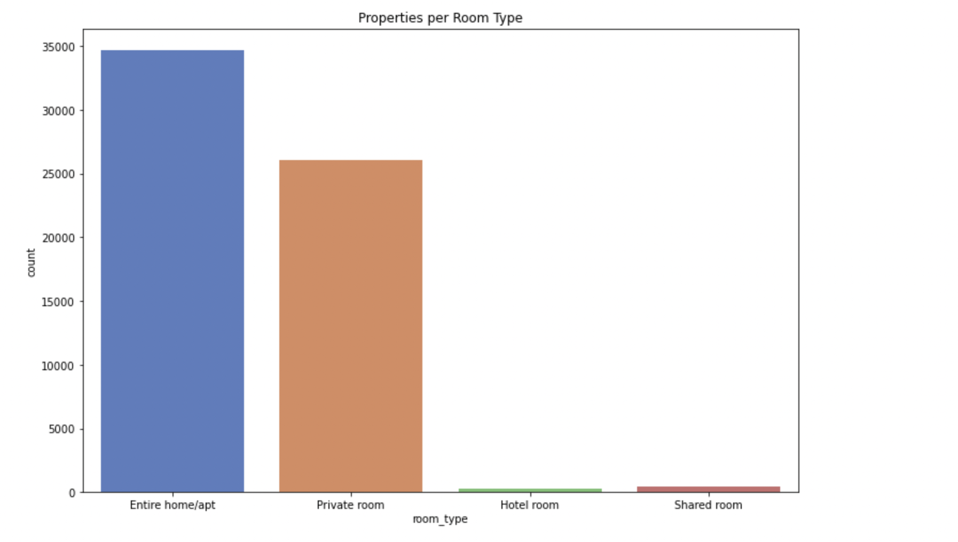

More than 30,000 entire home/ apt type rooms are followed by the private room of more than 25000. Hotel rooms and shared rooms are the least available room types in the property listings.

**Most listings are under which price?**

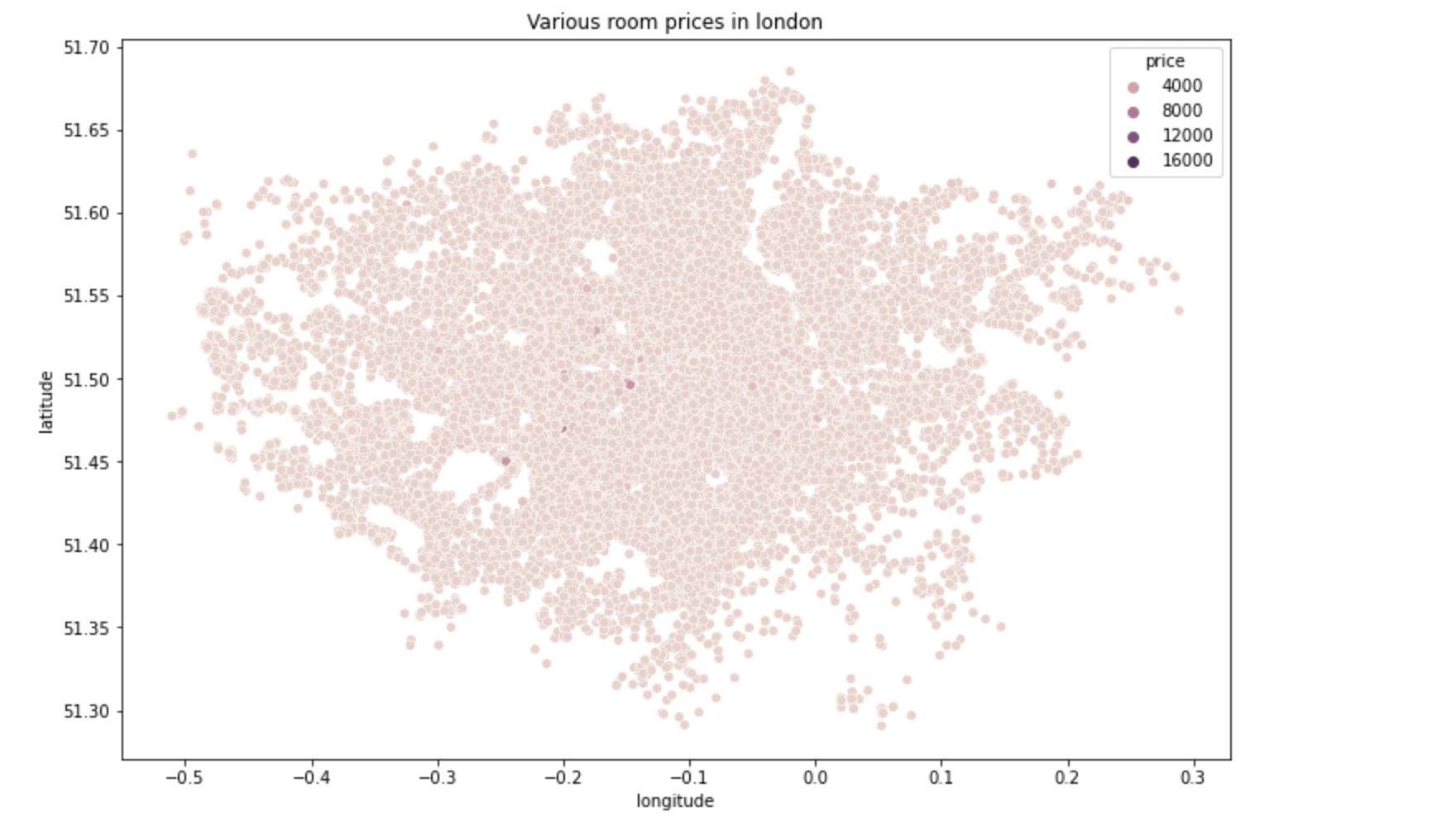

We have plotted the scatterplot between the longitude and latitude to know the distribution of price based on the location, and we found that most of the room prices are in the 4000s.

**Do the location and other features significantly impact the price of listings?**

We plotted the correlation matrix to see if any features significantly correlated with the price.

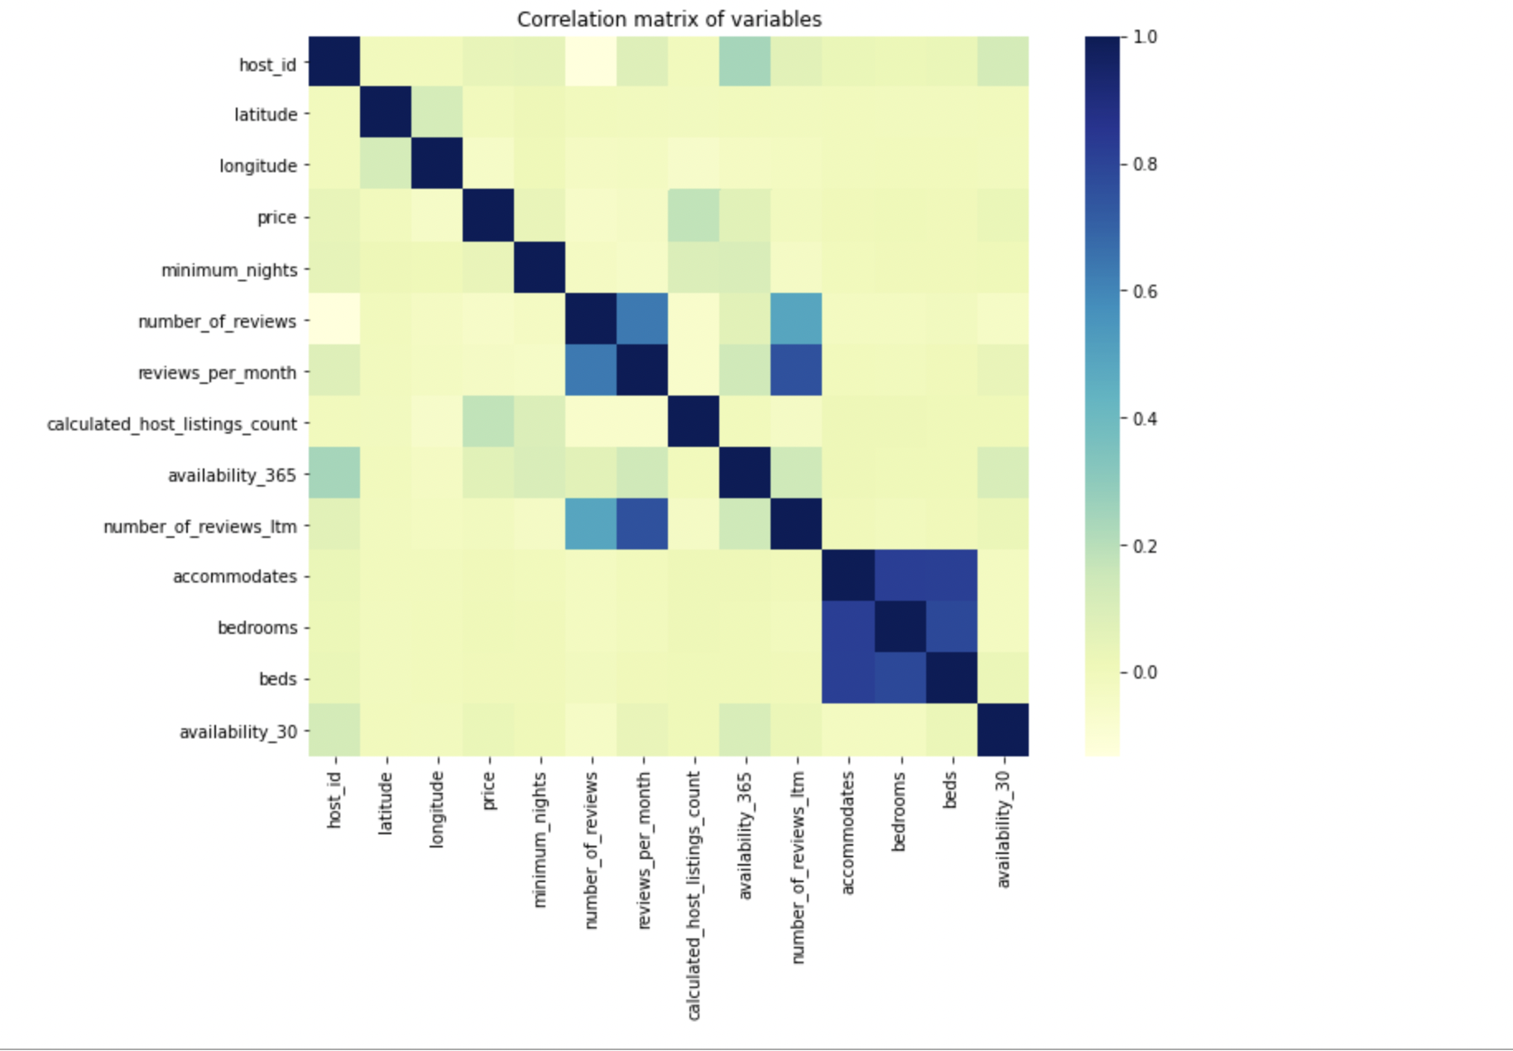

It disappointed us a bit as we discovered that the price doesn’t significantly correlate with other features. Several host listings and availability 365 had very little correlation, less than 0.2. Moreover, we can’t accurately determine the impact of location on the price as we correlated the price with longitude and latitude rather than combining them as a location.

So, we decided to cluster the data based on the location and predict the prices based on the cluster. If the expected model accuracy is high, we can conclude that the location significantly impacts the price.

**Data Mining Predictive models:**

Even though there is no pattern in the price distribution based on the coordinates, we decided to cluster the location data and predict the price based on each cluster because other price ranges in those coordinates might mask the price points.

**Clustering model:**

Since the Gaussian Mixture Models (GMMs) employ variance in addition to centroids to do clustering and the location data (GMM: Gaussian Mixture Models — How to Successfully Use It to Cluster Your Data?, n.d.) and I am using might have an elliptical shape, I chose GMM to cluster Airbnb location data.

Determining the number of clusters is a challenging and vital stage in grouping the data in any clustering approach with limited computer resources. I evaluated the best n cluster model using the Silhouette Coefficient to calculate the number of clusters. The better the model, the higher the score (Build Better and Accurate Clusters with Gaussian Mixture Models, n.d.).

We have extracted the location data, such as latitude and longitude, to the new variable london4 loc and transferred them to the new variable X for fitting the model because I am clustering the location data.

To store each Nth cluster, I've made an empty list. I used the N range of 2–10 clusters to determine which clusters had a high Silhouette score. I have looped the process of training the model using clusters from 2 to 10 and determining the score of each nth cluster rather than performing the same procedure repeatedly. Then, to analyze the data, create a line graph with the scores on the y-axis and the clusters on the x-axis.

Below is the plot for the scores of different clusters (GMM: Gaussian Mixture Models — How to Successfully Use It to Cluster Your Data?, n.d.)

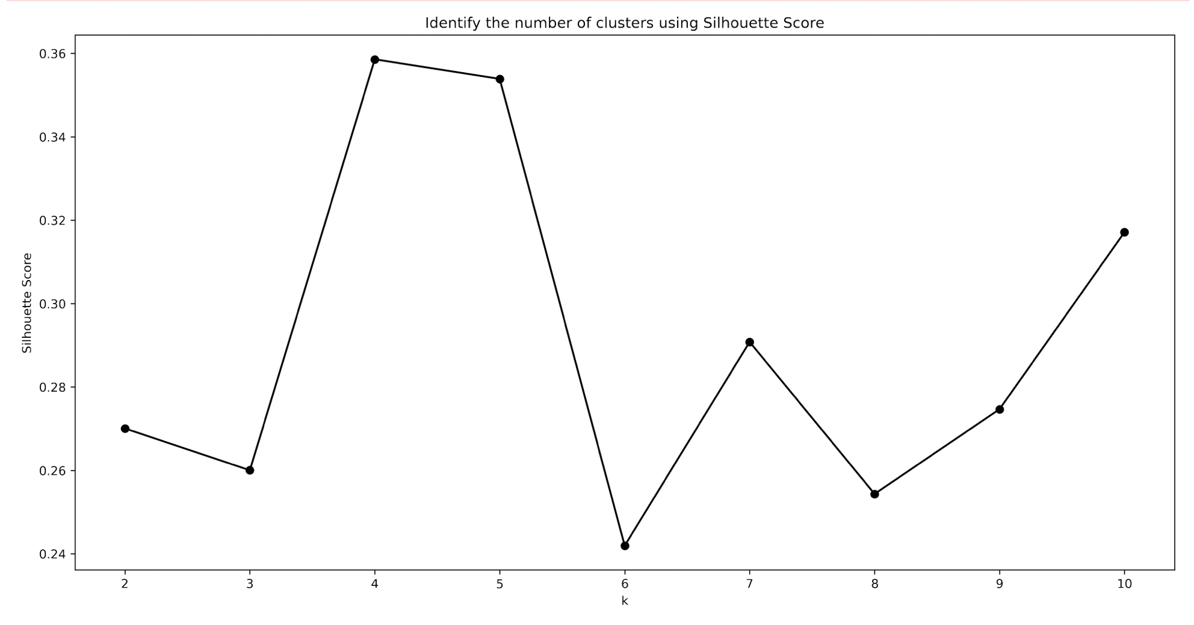

The four-cluster model has the highest score of more than 0.345, as seen from the graph above. The five-cluster model comes in second place, scoring about the same as the four-cluster model but with fewer points. Furthermore, none of the other clusters had a score greater than 0.34.

Below is the four-cluster model; we tried categorizing prices and color-coding, but it resulted in a scatter plot between the latitude and longitude with a color-coding price that we did in the EDA.

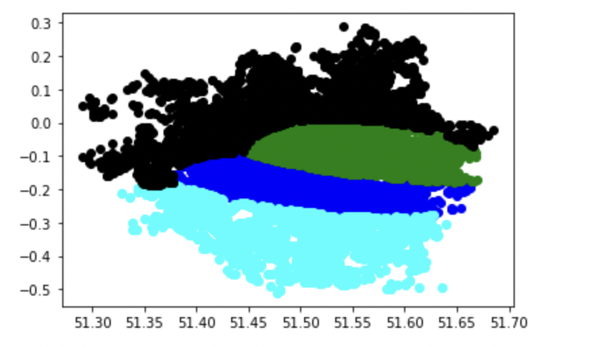

Below are the neighborhood names for each cluster. By predicting the price based on the cluster, we can predict neighborhoods' Airbnb hotel listings' price range.

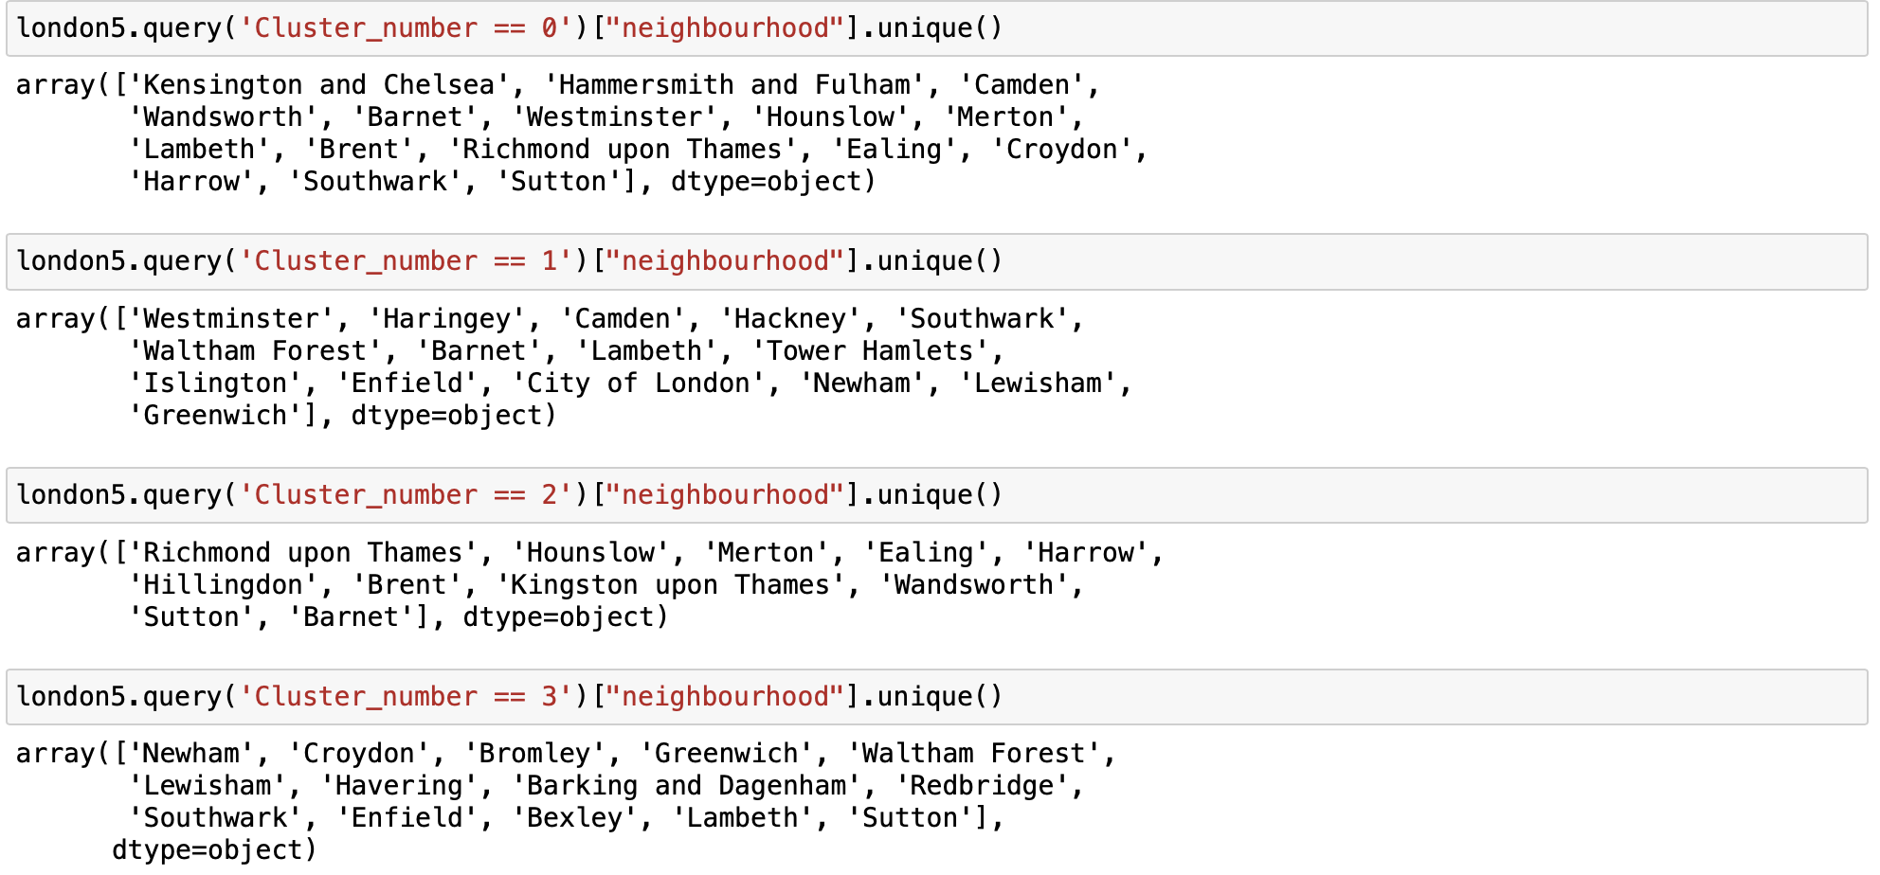

Then we predicted the price of each cluster using a random forest classification (Predict AirBnB Prices, n.d.) with the dependent variable as price and the independent variable as cluster number.

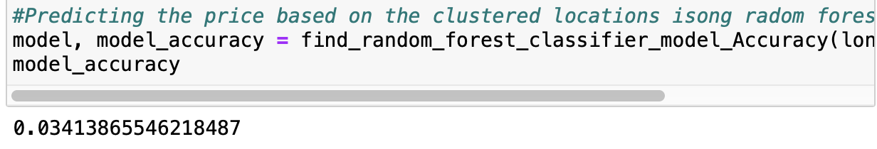

We got a very low accuracy of around 0.3%. As the model has low accuracy, the location is not a good feature to predict listings price, and location doesn’t influence the price.

So, we dropped the location data such as neighborhood, latitude, and longitude, and now we are left with ten variables, including label price. We classified the price based on the other nine variables using a random forest classification model. We see that room_type is a categorical string variable; we have encoded it in digits to fit the model.

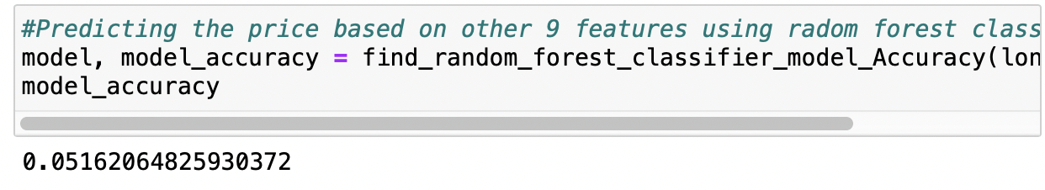

Though the accuracy is improved from 3 percent to 5 percent, we can’t rely on this model to predict the price.

We were intrigued to know essential features in the random forest classification. And we found that the number of reviews, calculated host listings count, minimum nights, price, and availability 365 are essential variables.

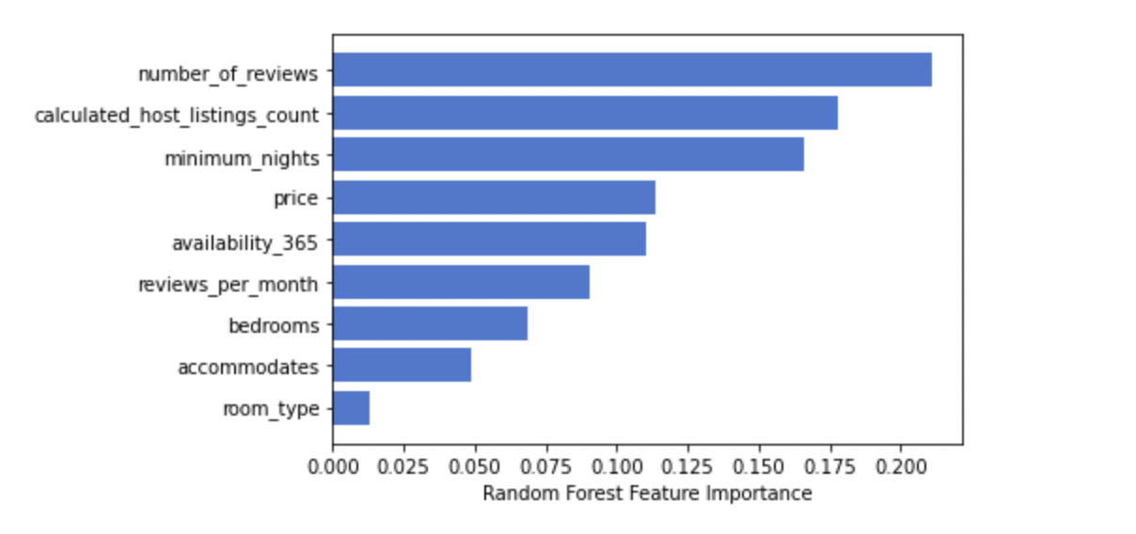

So, we extracted the top 5 essential features from the above random forest classification model to fit the model using them. But still, we got the same accuracy of around 0.5 percent.

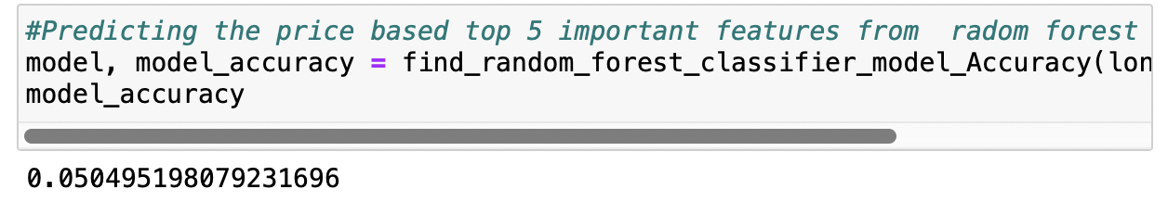

With this accuracy, using this model to predict the price is a bad idea. So, we decided to categorize the price into four categories of the price range: economic (less than 100), low-mid (between 100 and 250), high-mid(between 250 and 600), and high(greater than 600). Then, the price group was predicted based on the other ten variables using the K-NN classifier (Python Machine Learning Tutorial: Predicting Airbnb Prices, n.d.).

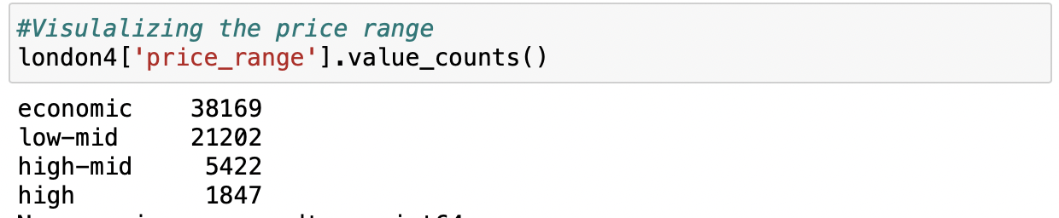

We have defined a function to split the data into training and test data in the ratio of 8:2, then standardizing, modeling the data, and finally return the best n-neighbor value and accuracy for the different values of n-neighbor from 2 to 50.

We classified the price range based on the price and other nine features. For n-neighbor value 3, we got an accuracy of 87.5 percent.

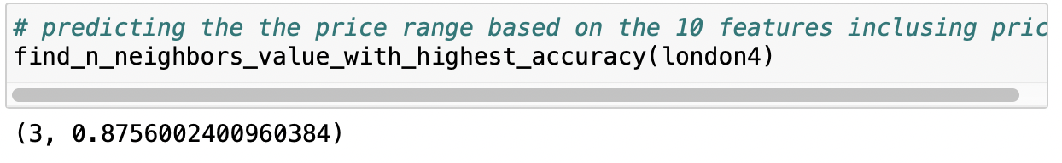

We wanted to predict the price range by excluding the price in the model because we defined the price based on the price and including the price in the model makes no sense. So, we dropped the price and classified the price range using the K-NN classifier.

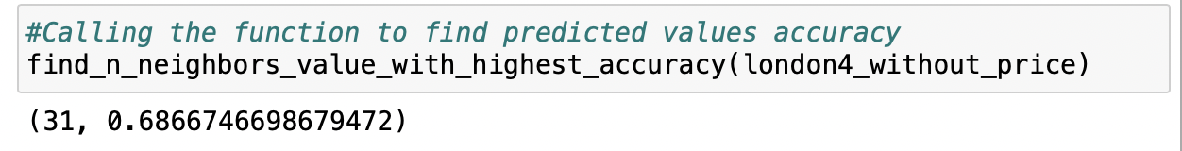

For n-neighbor value 3, we got the accuracy of 68.66 percent.

**Classifying the price range using the random forest classification.**

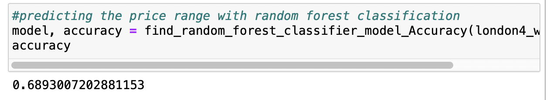

We got an accuracy of 68.93 percent with random forest classification—only a 0.27 percent difference between the random forest and K-NN classification.

Below is the feature importance contribution in classifying the price range for the random forest classification.

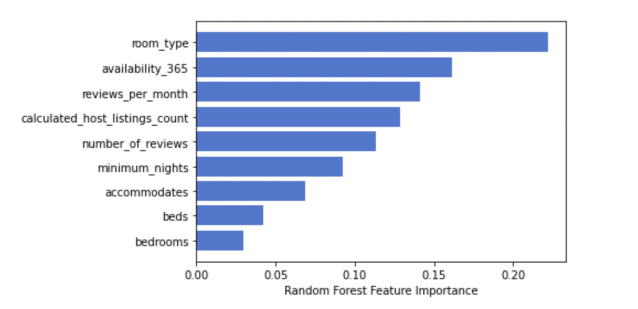

We classified the price range based on the top five essential features such as room type, availability_365, reviews per month, host listings count, and the number of reviews using the K-NN and random forest classification.

**K-NN classification:**

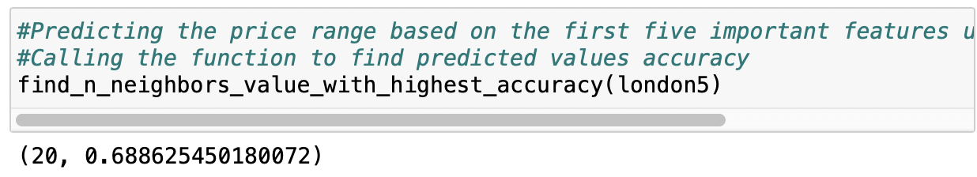

We got an accuracy of 68.86 for the n-neighbor value of 20.

Random forest classification:

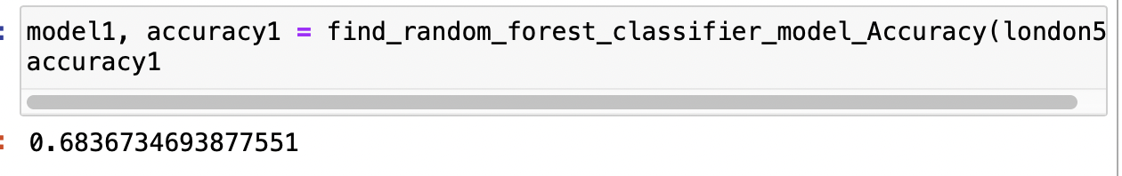

We got an accuracy of 68.36 percent, less than the K-NN classification.

**Comparison of models:**

Among all the models, the Random Forest classification model includes all the features in classifying the price range and has the highest accuracy of 68.93 percent. So, 68.93 percent of the time, the classified price range is accurate.

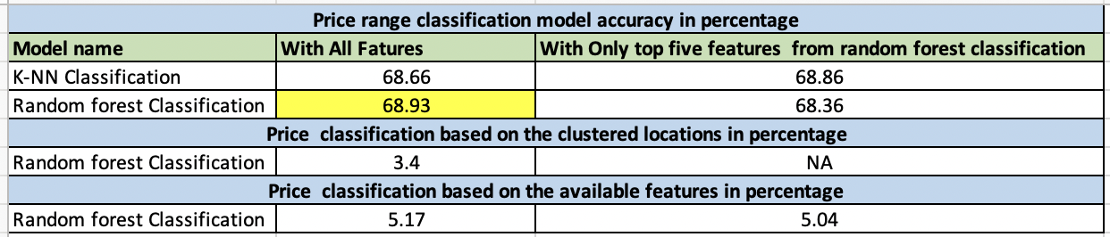

**Conclusion:**

We have used the Gaussian mixture model to cluster the data and predicted the prices based on the clusters using random forest regression as it helps in the feature section. We got a low accuracy for the fitted model. So, we grouped the price into four categories and classified the price based on the other essential features using the K-NN and random forest classifications. We got high accuracy of 68.93 percent for the random forest classification. So, we would choose this model rather than the other for its high accuracy.

**Recommendations:**

After classifying the price with the random forest model, we got a very low accuracy of 5 percent. With this data, we could predict the price correctly only five percent time. So, relying on this data and model to predict the price might not be a good idea.

Instead of classifying price, we grouped the price data into four categories based on the price range. With available data and a classified random forest model, we could classify the price accurately 68.93 percent of the time, which is better than the classifying price.

Considering these two points, I would recommend considering a classifying range of price it comes under rather than classifying the price

**Future work:**

We will try classifying the price and price range without the outliers and imputing the median and mode in the place of outliers. But we think there might not be much difference in the accuracy as there are only a few outliers in the dataset.

**References:**

* *A Guide to Data Clustering Methods in Python. (n.d.). Retrieved from builtin.com: https://builtin.com/data-science/data-clustering-python*
* *Build Better and Accurate Clusters with Gaussian Mixture Models. (n.d.). Retrieved from* [*www.analyticsvidhya.com*](http://www.analyticsvidhya.com)
* *GMM: Gaussian Mixture Models — How to Successfully Use It to Cluster Your Data? (n.d.). Retrieved from towardsdatascience.com: https://towardsdatascience.com/gmm-gaussian-mixture-models-how-to-successfully-use-it-to-cluster-your-data-891dc8ac058f*
* *Inside Airbnb. I am adding data to the debate. (n.d.). Inside Airbnb.*[*https://insideairbnb.com/get-the-data.html*](https://insideairbnb.com/get-the-data.html)
* *Impute missing values with the model in the Python code example. (n.d.). Grepper | The Query & Answer System for the Coder Community.*[*https://www.codegrepper.com/code-examples/python/impute+missing+values+with+mode+in+python*](https://www.codegrepper.com/code-examples/python/impute+missing+values+with+mode+in+python)
* *Pierre, S. (2020, June 8). Pandas tricks for imputing missing data. Medium*
* *The penalty for missing values in data science. (2019, February 8). freeCodeCamp.org.*[*https://www.freecodecamp.org/news/the-penalty-of-missing-values-in-data-science-91b756f95a32/*](https://www.freecodecamp.org/news/the-penalty-of-missing-values-in-data-science-91b756f95a32/)
* *ValueError: Series.replace cannot use DICT-value and non-none to_replace. (n.d.). Stack Overflow.*(ValueError: Series.replace cannot use dict-value and non-None to_replace, n.d.)
* *Visualizing distributions of data — Seaborn 0.11.2 documentation. (n.d.). seaborn: statistical data visualization — seaborn 0.11.2 documentation*
* *Varghese, D. (2019, May 10). Comparative study on classic machine learning algorithms. Medium.*[*https://towardsdatascience.com/comparative-study-on-classic-machine-learning-algorithms-24f9ff6ab222*](https://towardsdatascience.com/comparative-study-on-classic-machine-learning-algorithms-24f9ff6ab222)
* *Predict AirBnB Prices*. (n.d.). Retrieved from www.kaggle.com: https://www.kaggle.com/code/fireballbyedimyrnmom/predict-airbnb-prices/notebook
* *Python Machine Learning Tutorial: Predicting Airbnb Prices*. (n.d.). Retrieved from www.dataquest.io: https://www.dataquest.io/blog/machine-learning-tutorial/

**Appendix:**

Function to find the random forest accuracy model:

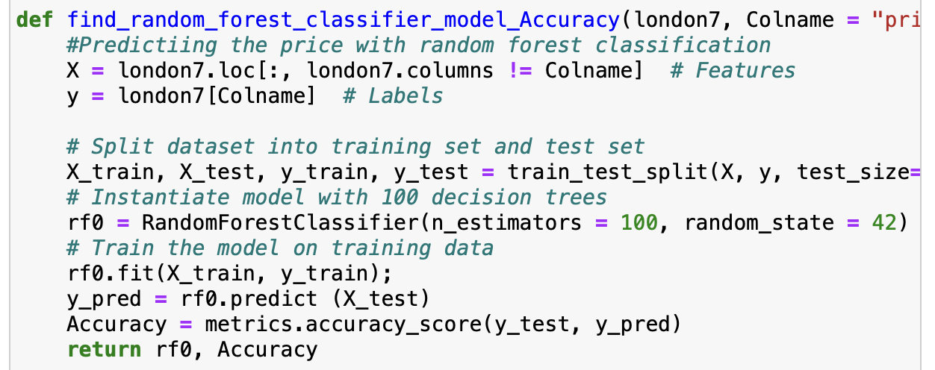

Function to find the best accuracy model for k values between 2 to 50.

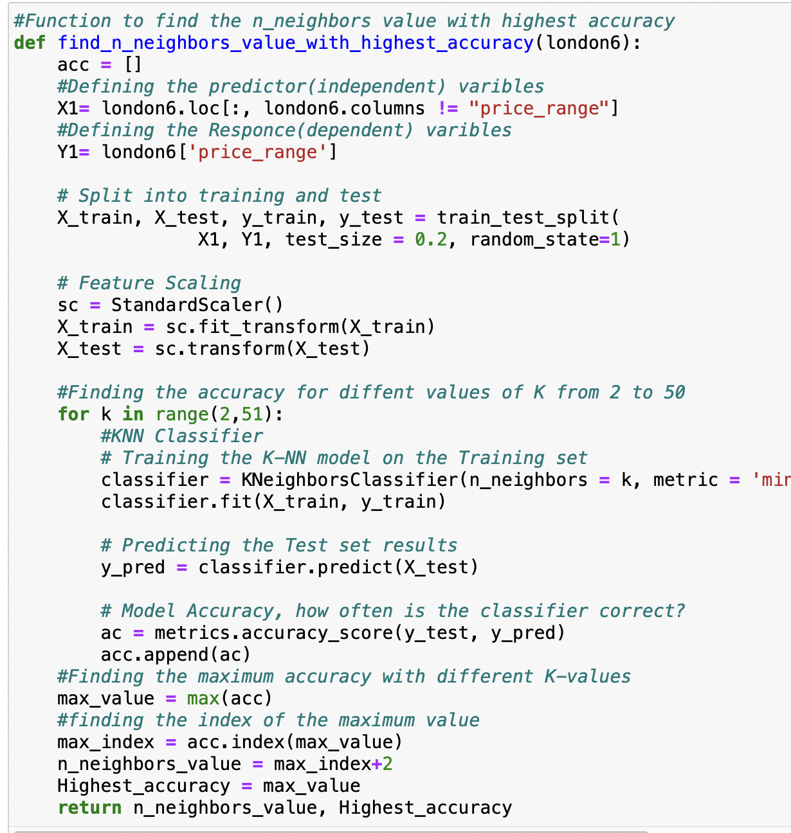

**Dataset information:**

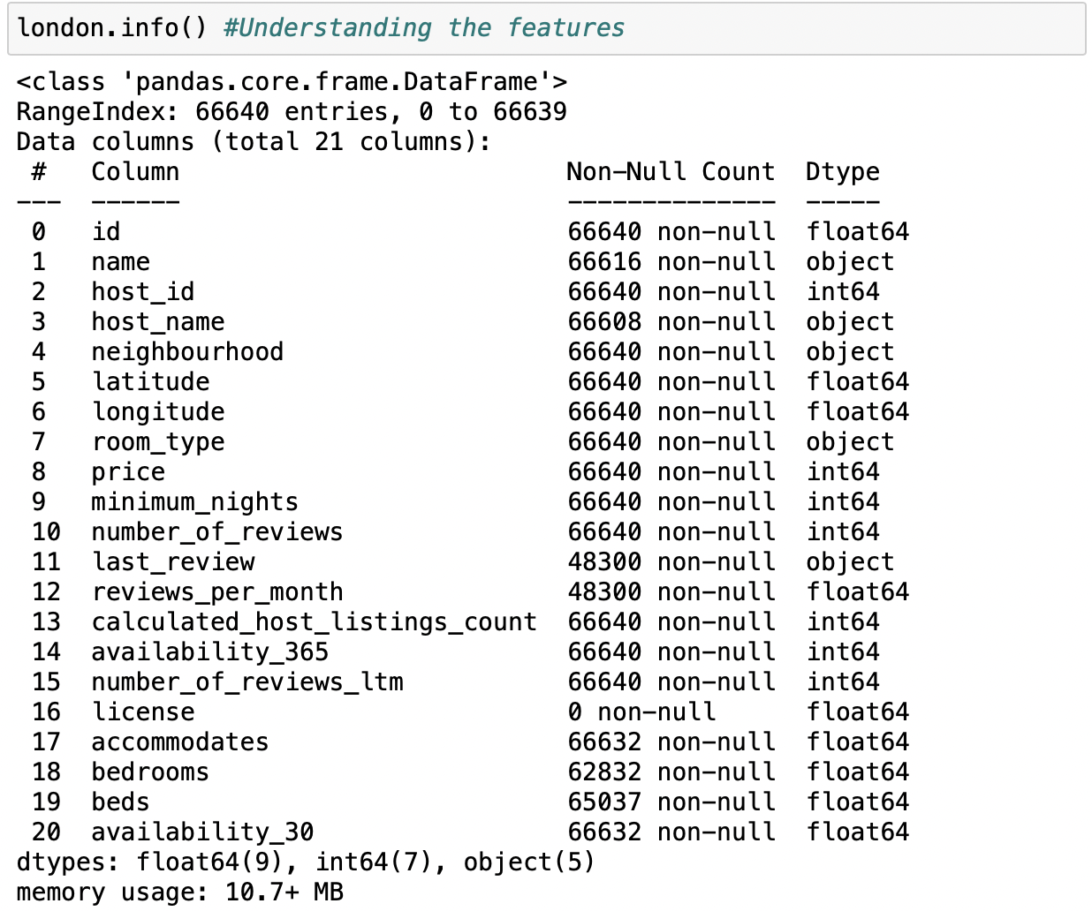

**Null values information present in the dataset:**

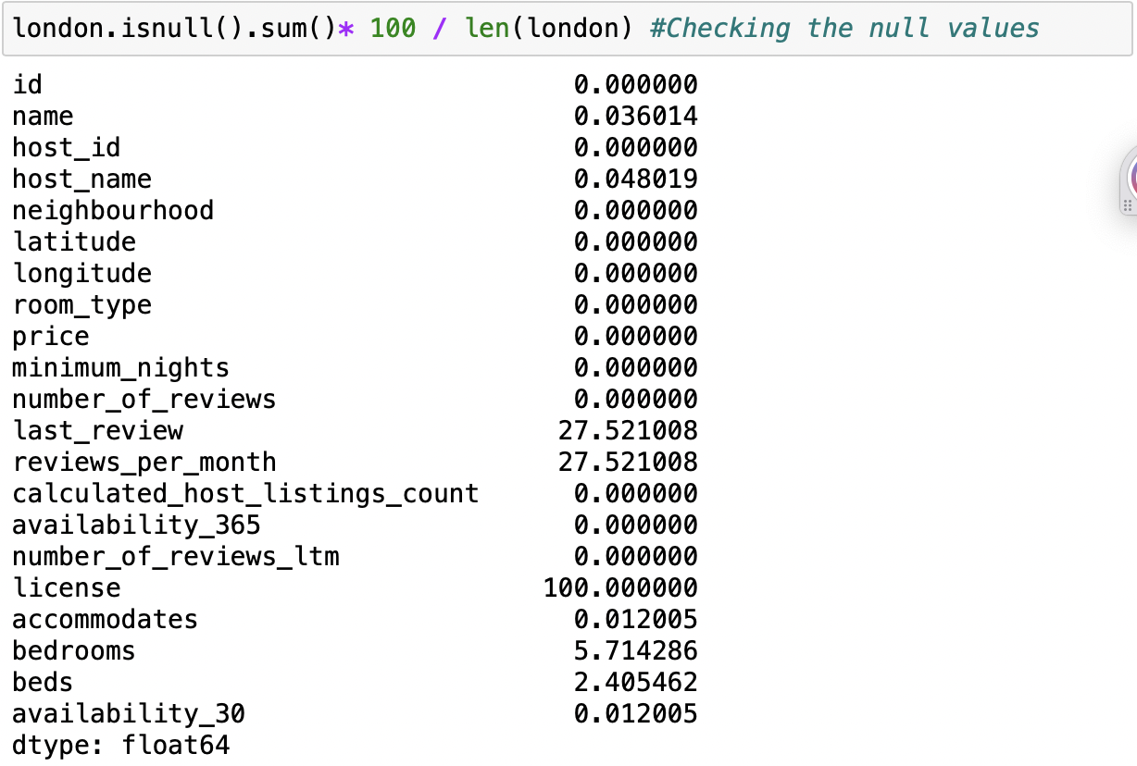

**Outliers’ information in the dataset:**

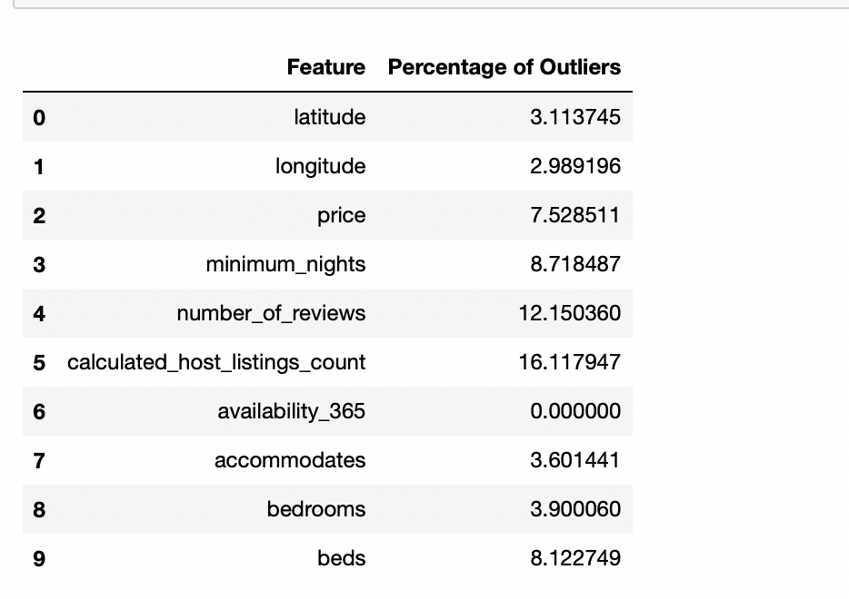

**Outliers’ information for the features that are used for modeling:**

